**Assignment 2**

Fetch the data from the table worker ,

select * from worker;

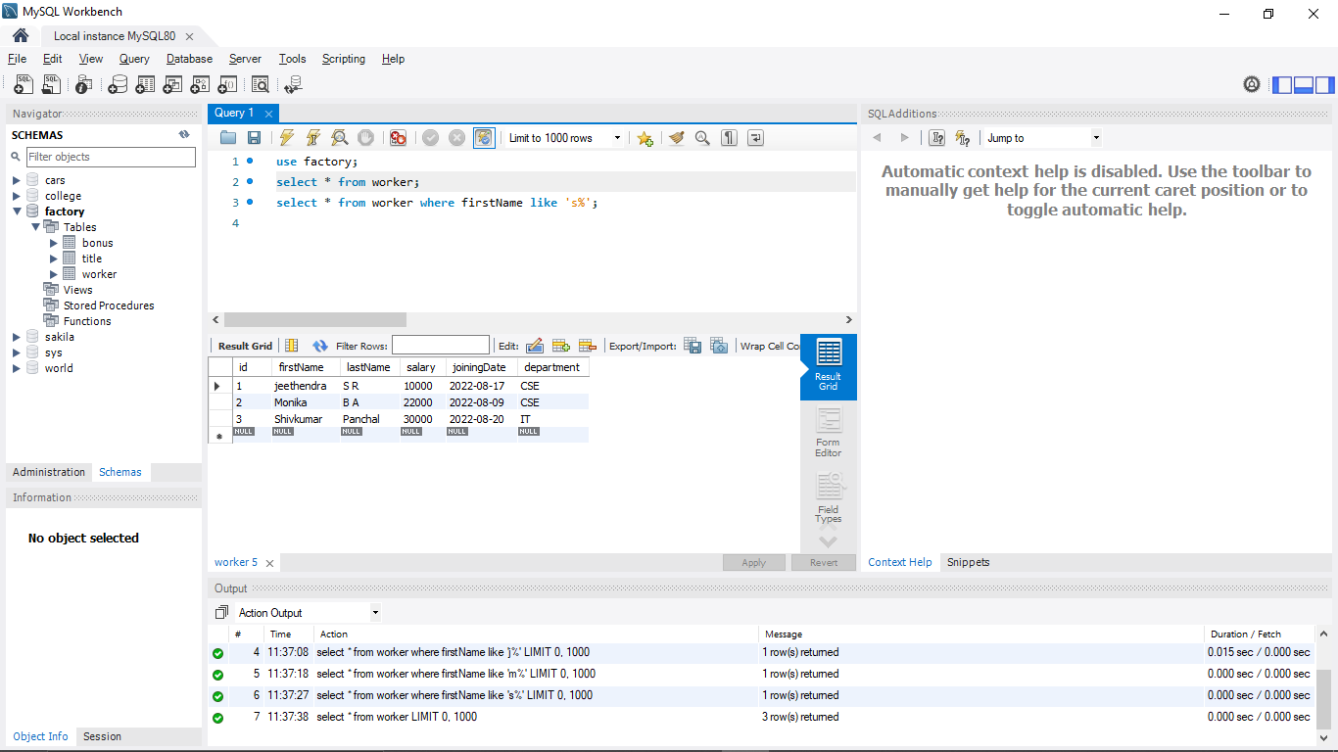

1)whose name start with anyone alphabet,

select * from worker where firstName like 's%';

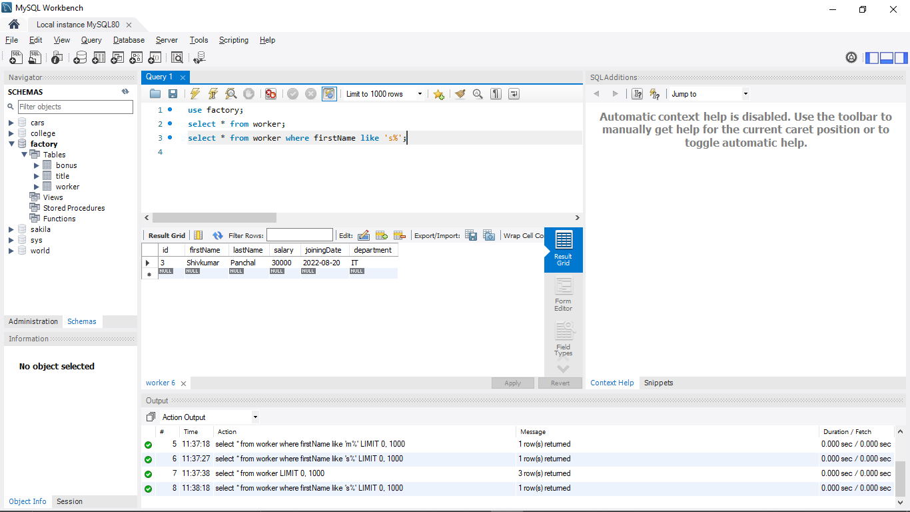

2)use Between operator to fetch the salary of worker

select * from worker where salary between 10000 and 25000;

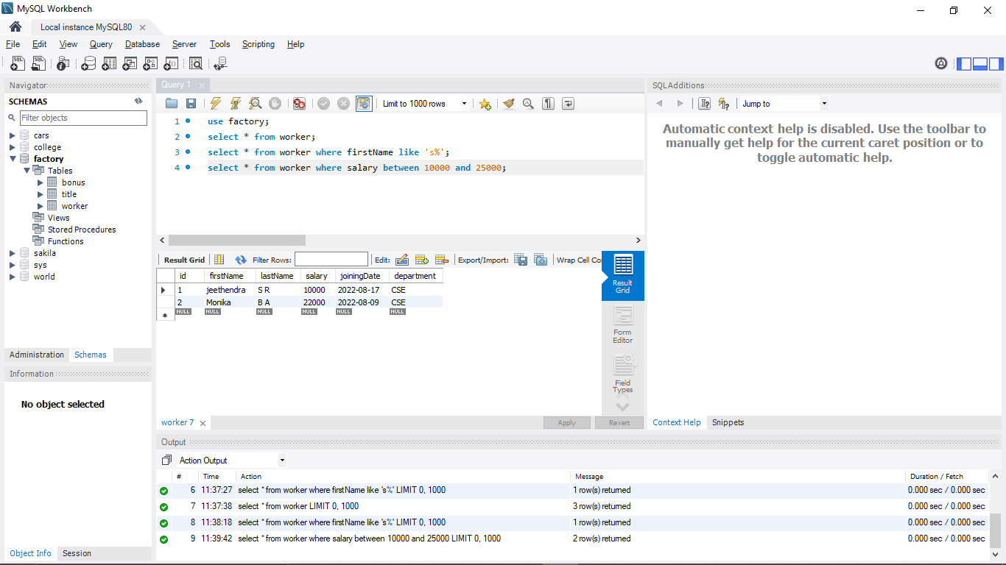

3)use AND operator & the wildcard operator to fetch the data of worker based on their departments &names

select * from worker where department = 'cse' and firstName like 'j%';

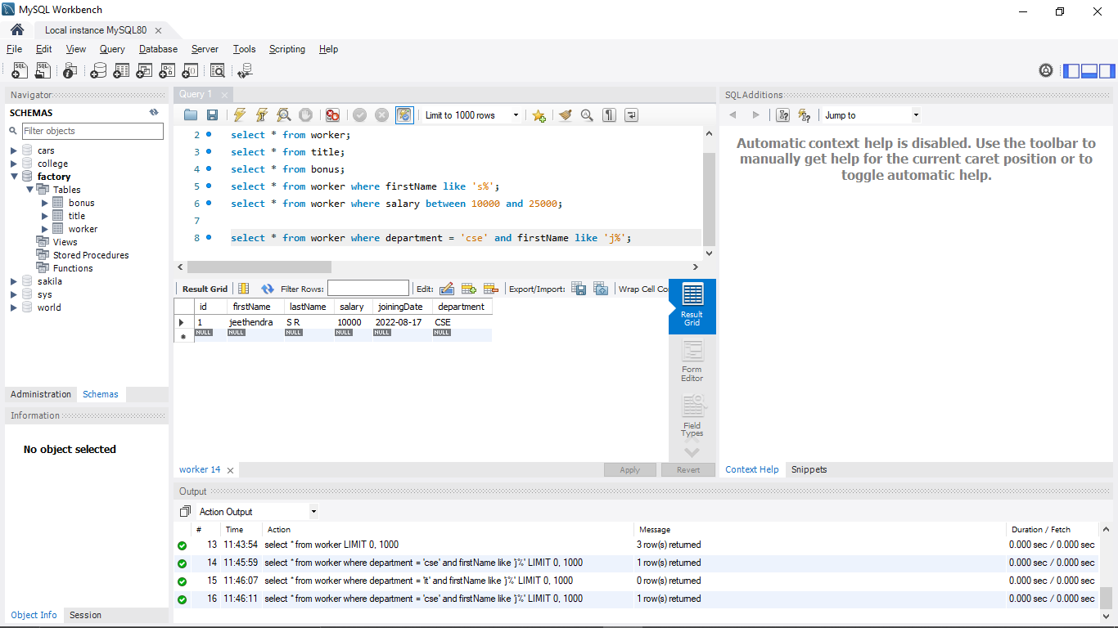

4)Fetch the data by their salary in descending order

select * from worker order by salary desc;

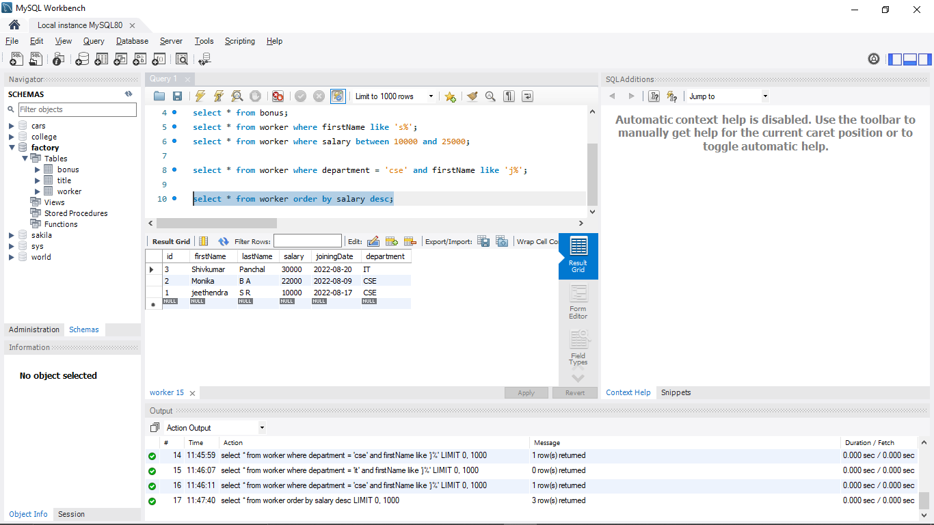

5)calculate the maximum salary from each department where salary should be greater than 50000.

select department, max(salary) from worker where salary > 50000 group by department;

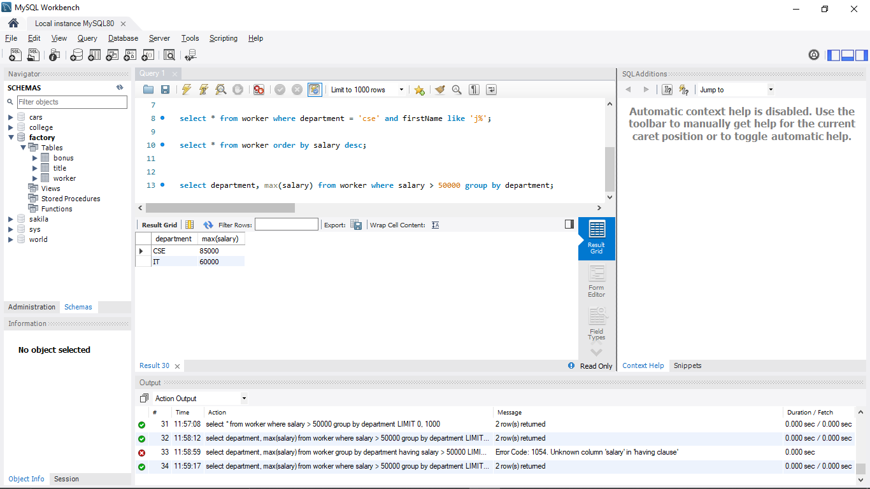

6)write SQL query to fetch details of the workers who are also the managers.

select * from worker as w join title as t on w.id = t.refId where t.workerTitle = 'Manager';

